Evidence Leaders in Education (ELEs)
Application and Reference Form
2021 - 2022

General Guidance

This form is set out in two sections. Section 1 is to be completed by you, the applicant and section 2 is to be completed by your referee. Once you have completed section 1, the form should be emailed to your Headteacher to complete the reference section.

You should submit the document to the Research School by uploading it on this electronic submission form – click here.

If you have any problems, please don’t hesitate to get in touch with Helen Froome, the Research School Administrator on hfroome1@satrust.com

It is strongly advised that applicants refer to the guidance and attributes of an ELE on the Research School website before completing their application.

Headteacher Reference

It is important that headteachers endorse the applicant’s intention to apply for the role of an ELE. You are therefore required to provide a reference from your headteacher that supports your application and validates your eligibility, capacity and relevant experience to perform the role and share your school’s commitment to support your role as an ELE.

Deadline: Friday 26th November 12 midday

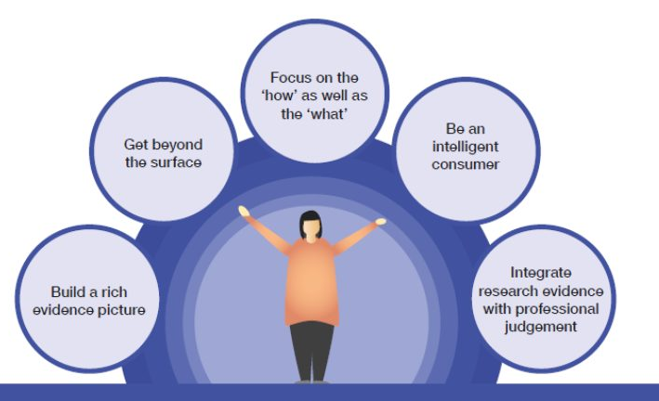
Section 1
To be completed by the ELE applicant

Applicant Details

Title
First name
Surname
Teacher Reference Number (TRN)

Role
School Phase
ELE Specialism - Literacy, science, SEL etc

School
Address
Phone
Applicant Email

Your Skills
Please indicate your skills and experience. Please tick all that apply.

Skills & Experience | Area of Strength | In my practice/  knowledge | Area I want to Develop in
Evidence-informed school/educational improvement (implementation)
Using a range of in-school data/information to identify issues and challenges
Understanding of evidence-informed change management/implementation
Developing evidence-informed strategies for educational improvement
Supported colleagues to use evidence and evidence-informed school improvement processes in educational settings
Show emotional intelligence in supporting colleagues to improve their practice
Influencing others to change
Experience of evaluating practice change within an educational setting
Supporting adult learning and professional development
Potential to lead or currently leading continuing professional development (CPD)
Coaching and mentoring skills
Facilitation skills
Able to communicate complex and nuanced information with clarity
Collaborate with other system leaders across the region
Engaging with and using evidence
Knowledge of the evidence base and considerations when using different evidence sources
Support colleagues in using evidence
Synthesising evidence from different sources
Specialist Expertise
Demonstrates understanding of the context and range of practice within specialist area (e.g. literacy)

Eligibility Criteria Confirmation

a) Do you hold a leadership role or responsibility within your school?

b) Please indicate how long you have been in this role. If less than two years, please provide details of your previous leadership role or responsibility and include the name of the school where the role was held.

Question 1
What motivates you to participate in evidence-informed system leadership and school improvement?

Question 2
Please outline the impact of your contribution as a leader in supporting practitioners and leaders in other schools or to your own school’s performance. Please detail the impact and demonstrate clear evidence of your practice within your area(s) of expertise or specialism.

Question 3
Please provide examples of where you have worked sensitively and collaboratively with peers/colleagues using coaching or facilitation skills to grow leadership capacity in others leading to sustainable improvements.

Question 4
Please provide an example of a time when you have significantly challenged, collaborated, motivated and/or inspired your colleagues to establish new, innovative working practices. What was the impact?

Question 5
Please provide details of activities engaging with evidence, research and/or evaluation that you have either led or contributed to. These can be in school or academic experience. Please refer to the headings in the table on page 3 to structure your answer.

Additional information
Please provide any other information that demonstrates your knowledge in support of your application.

Additional requirements
If you are successful, you will be invited to a face-to-face assessment. If you have any special requirements that they should be aware of, please state these below.

Section 2
Reference (to be completed by the headteacher referee)

ELEs are outstanding leaders, with at least two years’ experience and excellent knowledge of educational research practices and the evidence base. They work to support individuals and teams in other schools by providing high-level coaching, mentoring and support, delivering evidence-based CPD, and drawing on their knowledge and expertise in evidence-informed practices.

All applicants must meet the criteria to be accepted as an ELE. Each application is assessed against the eligibility criteria (see below). We therefore ask referees to take this into account when making a decision to recommend an applicant for the role.

Headteacher details

Name
Confirmation of role
School name
Email address
How long have you known the applicant?

1a. Please confirm the applicant’s current role.

1b. Does the applicant hold leadership responsibility within your school?

2. Please provide a supporting statement in the box below on how you consider the applicant meets the following eligibility criteria:

The applicant has:
- a successful track record of working effectively within their own school and/or across a group of schools, or working with a range of leaders within a single school;
- experience of successfully using coaching and/or facilitation skills to bring about sustainable improvements;
- excellent communication and interpersonal skills;
- an understanding of what constitutes evidence-informed practice and the ability and confidence to communicate this;
- an understanding of how their specialism and skills can contribute to wider school improvement goals;
- an analytical approach in identifying and prioritising needs;
- the ability to set and establish new and innovative working practices;
- the ability to grow leadership capacity in others.

3. Do you support this application and agree to the applicant being released from the school for a mutually agreed allocation of time?

4. Please provide evidence to confirm that the applicant has supported a middle or senior leader or group of leaders from another school or academy or within their own school.

5. Please tick a box below to indicate which statement matches your support for the applicant:

- I recommend this person unreservedly to undertake the role of an ELE ☐

- I recommend this person for the role of ELE, but have some reservations ☐

- I am unable to recommend this person for the role of ELE ☐

6. Additional comments

Thank you for taking the time to complete this form. If you have indicated that you have reservations in recommending or feel unable to recommend this applicant, we may contact you to discuss the position.

Submission Information

This word document must be submitted via the electronic submission form – an electronic receipt of submission will be sent.
In accordance with the Data Protection Act, the applicant you are providing a reference for has the right to view the reference, should he or she ask to do so. Please do not include any information that you would not be happy to discuss with the applicant as part of a professional conversation.

If you have any queries regarding this application, please our administrator, Helen Froome, for further help and support - hfroome1@satrust.com

Tammy Elward
Director of the Derby Research School

