Evidence Leads in Education (ELEs): Information/FAQs for ELEs
What is a Research School?
The Research Schools Network is a collaboration between the Education Endowment Foundation (EEF) and the Institute for Effective Education (IEE) to create a network of schools that will support the use of evidence to improve teaching practice. There are many evidence-based resources and tools available to help improve teaching practice and raise the attainment of pupils, but it can be difficult to get research into schools in ways that really make a difference in the classroom. Research Schools aim to lead the way in the use of evidence-based practice. Through the network they will share what they know about putting research into practice, and support schools in their region to make better use of evidence to inform their teaching and learning so that they really make a difference in the classroom.

What is the time commitment?

Depending on deployment requirements in different areas of specialism, we expect ELEs to be available to deliver around of six days support per year, the times and dates of which will be mutually agreeable to the client school, the ELE and the ELE’s home school.

What types of deployments might an ELE be asked to complete?

The role is varied. Some deployments might be to deliver training programmes (three day) or
communication events (one day events, conference presentations, Research Breakfasts or Twilights, workshops) whilst others might involve bespoke support for schools (individual or clusters). The deployments will be around an area of specialism.

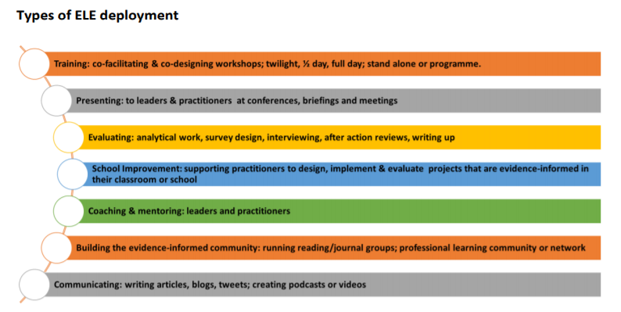

How will deployments be arranged?

The majority of deployments will be arranged via the Director of the Derby Research School
or the Deputy Director of the Derby Research School, and the priorities and requests of the
Research School Network. There may be times where you are approached directly by
schools/organisations requesting ELE support; these must be discussed and agreed with the
Director of Research School prior to confirming.

Can an ELE claim their daily remuneration rate directly if they are working part time in their
substantive post?

Yes, providing the deployment was completed on their non-working day. In this case, the ELE
must submit a claim form directly to the Derby Research School for payment. It is the
responsibility of the ELE to ensure that they are fully compliant with all tax requirements. In
these circumstances, the ELE must pay their own travel and other expenses.

What training will ELEs access?

There will be twice yearly ELE Training/Communication/Networking events at the Derby
Research School. These will be offered free of charge to ELEs, but the remuneration fee will
not be paid.

In addition, ELEs may be asked to attend training relevant to their specialism area in readiness
for deployments/delivering training (Deep Dives, Train the Trainers, Network Meetings). This
training will be provided free of charge to the ELEs. If an ELE wishes to attend any of the other
Research School Network training events for their own interest and professional
development, they can share this with the Research School director and we will support
these applications.

Are you recruiting ELEs from all phases?

Derby Research School’s remit is to support all school phases. We will accept ELE applications
from all phases and contexts

FAQs: Home School Headteachers, School Business Managers/Bursars and
Governing Bodies

How much will the ELE’s home school be remunerated?
The home school will be remunerated for ELE deployments at the rate of £300 per day. This
rate is fully inclusive of travel and other expenses unless specifically agreed with the Director
of Research School (no additional travel or other expenses can be paid if not agreed with
the Director of Research School prior to the deployment). No additional payment will be
made for planning, preparation or write up unless specifically agreed otherwise, in advance
of the deployment, with the Research School.

How will the school be remunerated?

A purchase order will be raised by the Derby Research School following the completion of
the package of support/programme of training and then payments will be made upon
receipt of a corresponding invoice from the ELE’s Home School. It is the responsibility of the
ELE to ensure that their Home School invoice the Derby Research School for payment.

How will an ELE’s travel or other expenses be paid?

The ELE should submit their travel and other expenses claim directly to their home school. The
home school should pay the ELE their expenses from the £300 remuneration rate.

How will additional agreed travel or other expenses be paid?

These will only be paid in exceptional circumstances (usually where we have been asked to
provide a service out of the immediate area and the organisation requesting support has
agreed to pay these travel/other expenses). In these cases, you should contact Helen
Froome (hfroome1@satrust.com) with your requirements, so that travel/other expenses can
be paid directly by the Research School (not claimed back later).

Do ELEs receive payment for the deployments?

This is at the discretion of the home school and should be negotiated between the ELE and
their headteacher/governing body. We would advise that, where the ELE is completing
planning/preparation work in their own time that this is recognised or that the £300 rate is
used to provide cover time for the additional workload.

