Remote teaching support guidance
This guidance draws upon recommendations from the EEF’s Covid-19 rapid evidence assessment and associated resources, several other sources, and from our experiences of teaching synchronous lessons to Year 7 and 11 classes between March and July 2020. The approach we took regarding the teaching of live lessons remotely was a decision based on our context.
The guidance below is provided to support teachers to plan a series of lessons. Some of the strategies are likely to be used every lesson, whereas some might be used once or twice in the teaching of a topic.
What? | How? | Why?
Lesson preparation slide  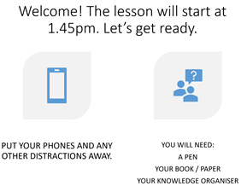 | Log on to start the lesson a few minutes early and put up a slide with information about what students will need for the lesson and how to organise their workspace. | This gives the teacher a few minutes to organise their resources so that the lesson starts smoothly. It also teaches students strategies and routines to help them to organise themselves and to be ready for the start of the lesson. Students will ‘turn up’ at different times to the remote lesson and so this slide also gives you time to check attendees and ‘chase up’ and absentees.
Welcome and use student names | Use the attendance list to welcome students as they turn up to the lesson, to reinforce the information on the preparation slide, and to support students in feeling a part of the class community. | When starting to teach remotely and trying to remember so many new things, it can be easy to forget the simple, but effective things that we would normally do in the classroom. Just as we would meet and greet students to lessons in school, it is important to use students’ names regularly and to welcome students.
Activate prior learning  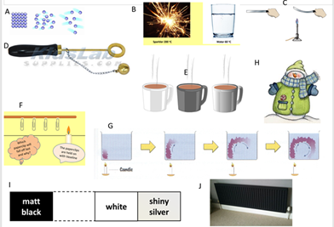 | It is important to first make the purpose of the retrieval practice activity clear to students and to try to ensure participation by all students.  Strategies might include:  - Knowledge retrieval quiz (students write answers in book / type them into the chat / use of Office Forms to create multiple choice quiz that provides immediate feedback)  - Show key images from previous lessons and ask students to type in key knowledge relating to each image into the chat  - Use of knowledge organisers to revisit previous topics that link to the new one | Students need to activate their prior learning in order to support them with new learning. In a classroom it is easier to spot which students are engaged in this task, and the danger is that only a few students will engage in this activity if there is no one watching over them. It is therefore helpful to use multiple choice questions so that the chat bar can be used by students to type in responses. The teacher can then monitor which students are responding. Office Teams quizzes are also useful in ensuring all students complete the activity. The problem with targeting individual students to provide answers verbally is that the other students aren’t having to think.
Communicate the learning journey and share the aims of the lesson(s) | Strategies might include:  - Learning journey ppt slides showing the build up of key questions over the course of the topic.  - Use of knowledge organiser.  - Use Microsoft whiteboard to show how the lessons have linked together.  - Lessons built around a topic key question that you keep referring back to.  - A lesson aims / learning objective slide.  - Regularly revisiting the learning journey of previous topics, showing how the topics link together. | This helps students to make sense of the links between the knowledge they are learning and the building of schema. By making the lesson / topic objectives clear then students will be more able to communicate their understanding and teachers will be able to more accurately assess student understanding.  Regularly revisiting previous topics and showing how they link together will also support the building of schema.
Teaching new knowledge | Strategies might include:  - Use of visualisers / graphics pads:  Focus most of your planning time on your explanations. Start with a blank page and gradually build up your explanation, thinking carefully about the words and images you are using. Being able to write on the screen also allows you to model live worked examples whereby you can share your thought processes whilst solving a problem, as well as the scaffolding of tasks.  - Use of PowerPoint:  If you don’t have access to a visualiser or graphic pad to annotate your screen then spend time adding images and words gradually to a ppt presentation rather than a text heavy presentation.  - Use of media clips and simulations  - Use of textbooks / media text:  If you have a visualiser then you can model reading strategies as you read through and annotate the text, before giving students the opportunities to do so independently. If not you can open up media text and talk through the strategies. | The EEF’s rapid evidence assessment into remote learning states that teaching quality is more important than how lessons are delivered. Teachers spending most planning time on the quality of instruction is important, especially when we are not in the classroom to be as responsive to students’ needs and re-teach / re-explain a concept. This problem can however be reduced if students are confident enough to communicate with the teacher during a lesson using the microphone or chat bar that they don’t understand something.  Starting with blank pages / PowerPoint slides and gradually building an explanation or modelling a strategy helps to focus students exactly on what is being taught.
Opportunities for students to practice / apply new learning  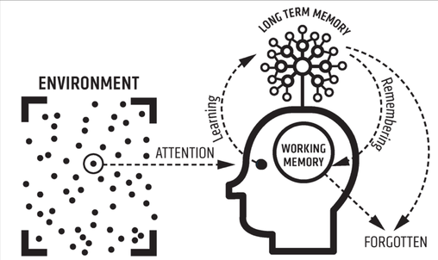 | Provide opportunities in a series of lessons / topic for students to practice something that has been modelled to them or to apply their knowledge.  Strategies might include the use of:  - Textbooks  - Workbooks / booklets  - Department resources  - Topic application questions  - Online resources | Students need to be thinking hard and engage with content if they are to transfer knowledge to their long term memory. It is therefore important that within a series of lessons / topic, students have sufficient time to practice.  It is helpful if the teacher remains ‘in the live lesson’ with the students whilst they do the task so that they are available to respond immediately to any student questions and re-explain the task if required. The teacher remaining live in the lesson also increases the expectations on students to complete the task.
Assessment and feedback | Make the purpose of each piece of work / assessment clear to students.  Strategies might include:  Assessment  - Submitting a photo of the work completed at the end of each lesson  - Quizzes (e.g Office Forms)  Office Forms quizzes allow you to identify misconceptions as they provide you with a question by question breakdown. Using the lesson chat bar for pupils to type responses allows you to respond promptly  - Application questions / assignments  Students can submit these to the teacher by taking a photo / emailing the document or submitting it on show my homework or Teams.  - Reflection questions- what have you learnt? What would you do if you were to do this again?  Feedback  - Focus on the strategy and effort over outcome.  - Showing examples of students’ work submitted.  - Showing the question by question breakdown of the quiz and unpicking misconceptions  - Whole class feedback sheets  - Live assessment of a few pieces of students’ work in the lesson using a visualiser / graphics pad.  - Use of Microsoft Teams assignments page to type an individual response to each student.  - Email responses | Having high expectations of students to submit work, and by providing regular feedback on the strategy will help to keep students’ motivated. There are several ways this can be done that minimises teacher workload, and increases the impact, such as live feedback and asking students to reflect on what they have learnt.  Focusing feedback on effort and strategy will show students that you value these over outcome.

Related HISP RS blogs:
Reflecting on remote teaching: Exemplifying several strategies
https://researchschool.org.uk/hisp/news/reflecting-on-remote-teaching/
What we have learnt from remote teaching and how it will impact our teaching when back in the classroom
https://researchschool.org.uk/hisp/news/blog/

HISP RS remote teaching workshop webinar link:
https://www.youtube.com/watch?v=4SsAGZ0O2JQ&feature=youtu.be

References:
EEF Remote learning rapid evidence assessment
https://educationendowmentfoundation.org.uk/covid-19-resources/best-evidence-on-supporting-students-to-learn-remotely/#nav-best-evidence-on-supporting-students-to-learn-remotely

EEF Covid-19 resources for schools- Home learning planning template
https://educationendowmentfoundation.org.uk/public/files/Publications/Covid-19_Resources/Resources_for_schools/Home_learning_approaches_-_Planning_framework.pdf

ResearchEd Home: Ten tips for emergency remote teaching- Paul Kirschner
https://researched.org.uk/sessions/paul-kirschner-ten-tips-for-emergency-remote-teaching/
Chartered College: https://my.chartered.college/2020/03/online-distance-and-home-learning-selected-reading/
Rosenshine’s Principles of Instruction: https://www.teachertoolkit.co.uk/wp-content/uploads/2018/10/Principles-of-Insruction-Rosenshine.pdf and https://static1.squarespace.com/static/58e151c946c3c418501c2f88/t/5bcad7810d929703affe7abb/1540020098430/Rosenshine+Principles+red.pdf
SLOP booklets : https://cogscisci.wordpress.com/
ResearchEd Home: Adam Boxer: https://researched.org.uk/sessions/adam-boxer-dual-coding-for-teachers-who-cant-draw/
ResearchEd Home: Oliver Caviglioli : https://researched.org.uk/sessions/oliver-caviglioli-dual-coding-to-organise-ideas/
Daisy Christodoulou
https://daisychristodoulou.com/2020/04/the-challenge-of-remote-teaching-is-the-challenge-of-all-teaching/

Mark Enser
https://www.tes.com/news/coronavirus-5-point-model-deliver-online-learning

