Cornwall Research School Evidence Advocacy Network (CRS EAN)

Evidence Advocacy is defined as:
“Influencing existing systems and structures to be more evidence informed.”

“Advocates and other individuals and intermediary organizations are active agents
of research and play an important role in research use. They interpret research and
affect what knowledge is shared, with whom, whether it is used, and to what end.
They intentionally permeate boundaries of organizations and institutions, introduce
vendors, and fuel movements, yet are often not considered in the design of
strategies to improve research use.”
DuMont, K. (2024). Doing better by children: Studying ways to fully leverage ideas and findings from research. William T. Grant Foundation.

Cornwall Research School (CRS) are developing a network of evidence advocates. The purpose of this network will be to support CRS, the wider Research School Network (RSN) and the Education Endowment Foundation (EEF) in fulfilling the mission to break the link between family income and educational achievement. This will be done by influencing systems and structures to be more evidence informed.

We are looking for Evidence Advocates to join our network.
We are seeking EAs from Cornwall, Devon and across the Southwest and from school settings of all types and phases.

If you are interested in joining CRS EAN please complete the expression of interest form here.
Evidence Advocates will be individuals within education that share our passion in addressing these aims. They will be individuals who are able to demonstrate the following criteria:
1. Credibility and reach
2. Knowledge and experience (e.g. around evidence informed process and practice)
3. Communication skills and intentional planning
4. How they enact the role (e.g. with humility, passionate about moral purpose etc.)
5. Collectively their representativeness of the profession (e.g. personal backgrounds and organisational backgrounds)

A rubric for these criteria is being developed by the EEF. See image below for a draft representative example of what this might look like.

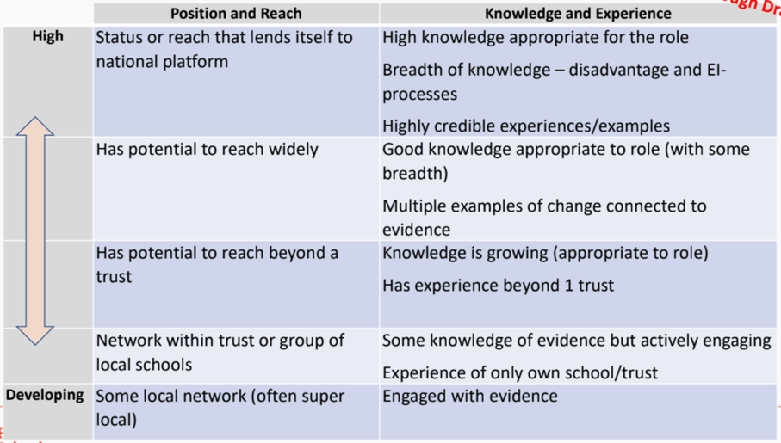

Evidence advocates will support CRS in advocating for evidence, supporting with its engagement and use in all educational settings in Cornwall and the Southwest. The evidence advocacy network (CRS EAN) will be engaged with the act of building a community around evidence. Advocacy will also focus on the importance of understanding and addressing socio-economic disadvantage.
Areas to highlight:
- The continuing importance of a focus on socioeconomic disadvantage
- The significant attention to childcare and the early years
- The infrastructure to support evidence-informed practice in education

CRS are working withing the framework of the RSN Regional strategy. This strategy is comprised of areas of work seen below.

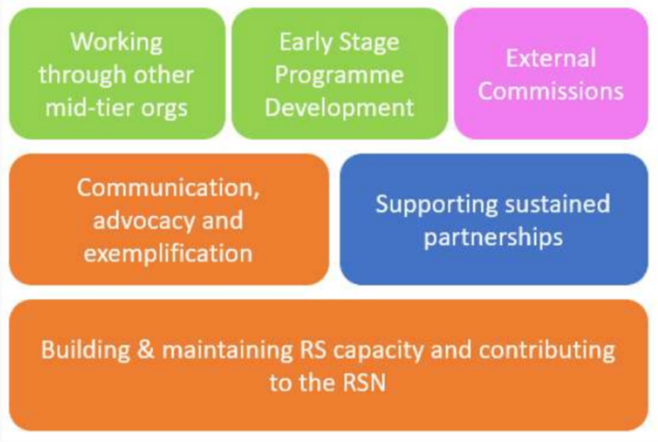

The CRS EAN will hold regular meetings for all evidence advocates.

The group meet once a term for 75 minutes. The meetings will provide opportunity for the CRS core team to support the EAN with updates, RSN and EEF news, relevant training, research summaries and resources.

Following the meetings the EAs are expected to:
- Disseminate research and resources to colleagues
- Work with teaching and learning leads to help inform CPD
- Read and keep up to date with the latest EEF reports and associated educational research
- Role model evidence-informed practice to other colleagues and capture and share best practices as high-quality case studies
- Collaborate with senior and middle leaders to support evidence informed decision making in school
- Network with other local research advocates.

We would also ask that EAs contribute to the work of CRS by:
- Writing a minimum of 1 blog per year
- Deliver a minimum of 1 session per year (webinar, conference, evidence briefing etc)
- Contributing towards CRS content a minimum of once per year (video, podcast, animation, evidence booklet etc)

We hope that establishing a core group of Evidence Advocates is a sustainable approach to ensure:
- Schools in Cornwall and the Southwest have a designated member of staff who is kept abreast of the latest emerging and updated research and evidence
- A broader range of staff in each school are engaging with evidence, to inform their decision making
- Collaboration and sharing of best practice develop between schools
- Developmental opportunities are provided within schools, to maintain motivation and interest and support recruitment and retention of high-quality teachers

Benefits for Evidence Advocates:
- Professional Development: Exposure to cutting-edge research, access to the RSN and EEF network, and participation in professional discussions fosters growth. Deeper understanding of the evidence around a variety of issues.
- Leadership Opportunities: Advocates gain visibility in their schools and can take on leadership roles in promoting evidence-informed practice.
- Collaboration: The network provides opportunities to learn from colleagues and share best practices, fostering a sense of community.
- Problem-Solving Skills: Advocates develop skills in translating research into actionable strategies for their schools.

Benefits for Schools:
- Improved Decision-Making: Evidence advocates ensure schools base decisions on sound research, leading to more effective practices.
- Sustainability of Impact: The network sustains the momentum gained from initial research projects, ensuring long-term benefits.
- Improved Implementation: EAs will develop and share a deep understanding of the evidence around implementation which will support their setting and lead to improved implementation of practices and strategies.
- Teacher Retention: Professional development opportunities and the focus on effective practices can contribute to teacher satisfaction and retention.
- Collaboration: Schools can share resources, best practices, and challenges within the network, leading to improved outcomes across all institutions.

If you are interested in supporting CRS as an evidence advocate please complete the expression of interest form here.

